INDIAN INSTITUTE OF TECHNOLOGY PALAKKAD

ID1050A ENGINEERING DESIGN

**Final Design Document**

December 1st, 2023



**Title:** Open Faucet/Running Water Detection System

**Team Members Details:**Project ID: P21

Team Leader: [RAAGAM HITESH PARMAR](mailto:112301024@smail.iitpkd.ac.in) 112301024

Team Members:

[BEERE HARSHITHA](mailto:102301006@smail.iitpkd.ac.in) 102301006  
[PUPPALA DHANUSH](mailto:102301029@smail.iitpkd.ac.in) 102301029  
[GUBBALA SAI DEEPA](mailto:112301008@smail.iitpkd.ac.in) 112301008  
[MULLAGURI TEJASWINI](mailto:122301027@smail.iitpkd.ac.in) 122301027  
[NUNNA KUMAR BUCHAIAH CHOWDARY](mailto:132301023@smail.iitpkd.ac.in) 132301023  
[PALLA DHANURVIKRANTH](mailto:132301025@smail.iitpkd.ac.in) 132301025  
[MEKARTHI VIVEK CHAITHANYA](mailto:142301024@smail.iitpkd.ac.in) 142301024

**Problem Statement:** Running water due to open taps/faucets causes a lot of wastage of water and frustration on the user’s end

**Identification of user need:** I have personally experienced the problem at my home. My mother used to check every tap after we had guests to make sure none of them are open. She sometimes left them open by mistake which led to the tank running dry.  
Many similar events have happened in the hostels here. I have seen taps partially open or not fully closed in the washrooms.

**Research conducted:**

* Checking out different methods which can be used to detect small flow of water, which includes [Ultrasonic](https://en.wikipedia.org/wiki/Ultrasonic_flow_meter) and [Electromagnetic](https://en.wikipedia.org/wiki/Magnetic_flow_meter) methods
* Finding out how a faucet works
* Finding out how much time people take to wash their hands

**Solutions already present:**

* Automatic Faucet Shutoff Systems based on spring-loaded faucets, similar to Faucets in Saraswati Block
* Taps which turn on when you put your had close to it.
* Pipes fitted with electronic valves which can be controlled over the air with an app.
* There are indirect solutions like leakage detector, which lays on the floor and detects presence of water on the floor. [Source](https://www.moen.com/flo)
* Some industry-grade solutions include a thermal imaging camera which detects changes in temperature to detect water leaks. [Source](https://www.indiamart.com/proddetail/thermal-camera-for-water-leaking-leakage-detector-ht-18-21856629888.html)

**Merits:**

* + These systems are quite reliable and proven
  + The electromagnetic system is quite innovative and can detect small amounts of flow of water
  + They often come with a mobile app for ease of operation

**Demerits:**

* + They are more expensive than normal faucets
  + The problem is not resolved 100% using these solutions as these systems do not detect whether the water is flowing or not but they shut off the faucet after a predetermined amount of time has passed.
  + They may not be practically usable for a common man, e.g., you can’t just replace every single faucet with smart ones in every single house to solve the issue.
  + The ultrasonic method detects small flow of water but only when the sensors are submerged in the water, otherwise the sensor won’t work.

**Proposed solutions:**

I would prefer my solution to be flexible so it can be attached to many pipe/opening sizes

* A flexible hydrophobic film can be used as a base and two electrodes can be stuck onto it. This flexible contraption can then be bent into a circular shape and be put inside pipes. The hydrophobic film will be at an angle to remove any excess water from between the electrodes. There may be some water on the electrodes, but none between them, so they are not conducting yet.  
    
  When the water flow is fast enough, the hydrophobic film will be unable to keep the water away from between the electrodes and the circuit will be completed.  
    
  This system will be placed at the end of faucets for ease of installation.  
    
  **Pros:**

1. The system is flexible; hence it can fit into any pipe fixture.
2. The sensor can be connected to any other system which can further send the message to the user via different interfaces.
3. It can be replaced easily.

**Cons:**

1. It doesn’t take into account that the water pipes will be mostly full when no water is flowing, hence giving an *always high* signal, which is not useful.
2. It detects the flow of water by checking its presence against certain conditions, but it may lead to may false positives.

**Sketches:**

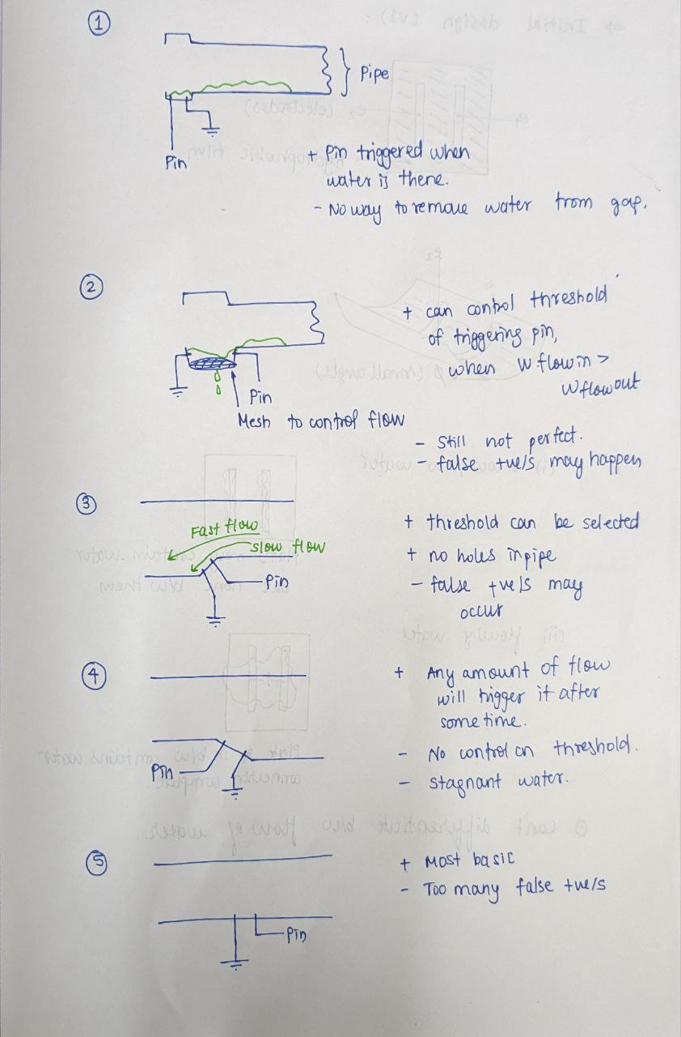

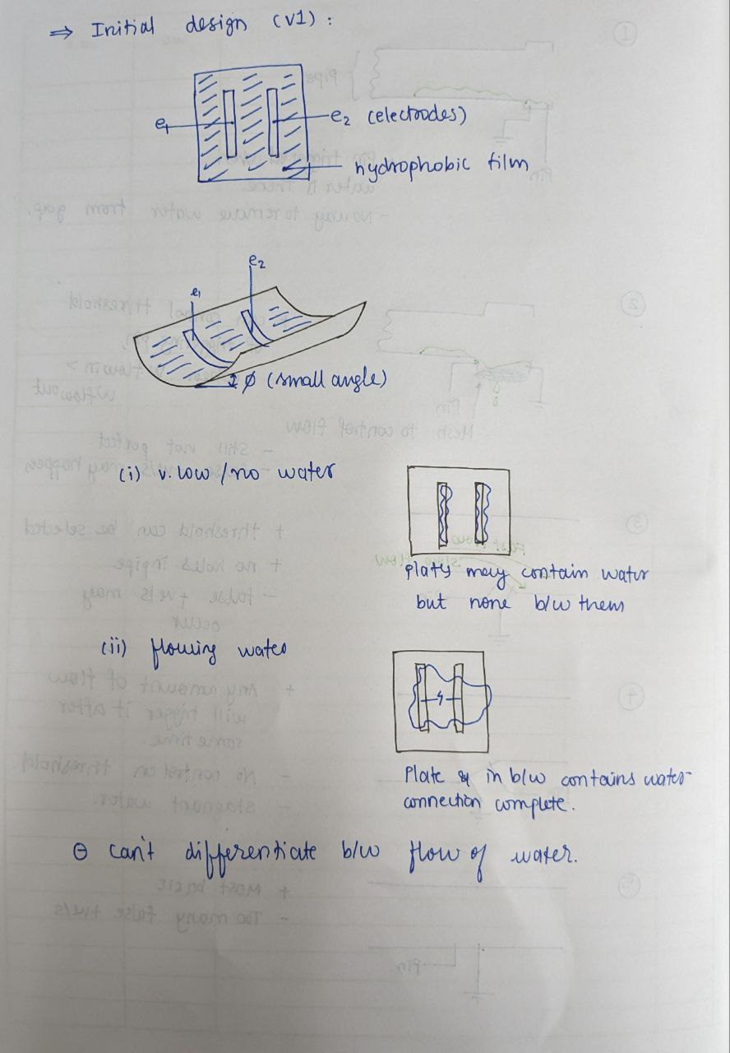

* A similar flexible hydrophobic film, but this time the electrodes will be of full length of the film, which can wrap across the entire pipe. The system will measure the resistance of water across the electrodes. More water will cause less resistance across the electrodes.  
    
  This improved system will detect the amount of water present at the end of the faucet at any given time and the sensor can be connected to any other systems which can further send the message to the user via different interfaces.

**Pros:**

1. The system is flexible; hence it can fit into any pipe fixture.
2. The sensor can be connected to any other system which can further send the message to the user via different interfaces.
3. It can be replaced easily.
4. It is more reliable than the previously proposed solution and can provide more data with similar amount of electrical and physical components.

**Cons:**

1. Under certain conditions, it may not work as expected due to some assumptions taken during designing of the solution
2. We planned to use the above system in front of a running faucet, but that is not possible as the faucets have a guard in front of them to prevent large particles into the water stream. This system can still be used in the waste pipe of the sink

**Sketches:**

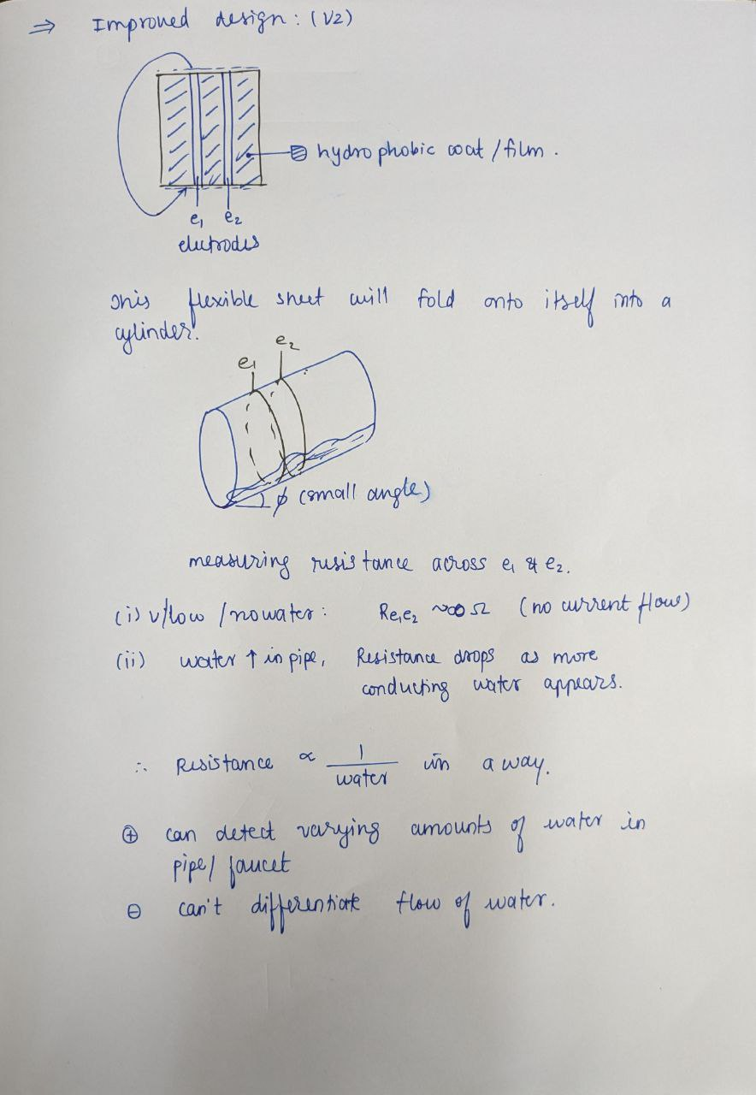

* 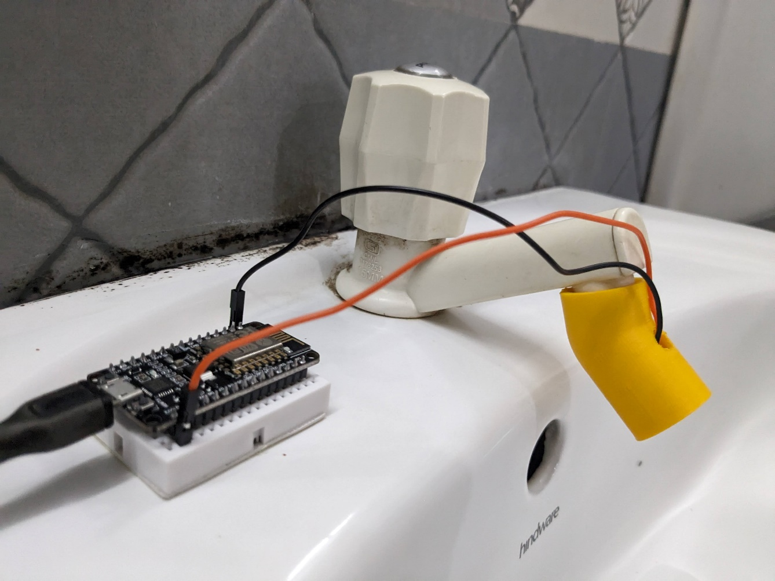A 3D printed tube which can be fit on the tap opening with the electrodes as rectangular ribs, also 3D printed, which are covered in Aluminium tape. There will also be hydrophobic film in between those electrodes just as proposed earlier. A Wi-Fi enabled prototyping board based on ESP8266 called Nedelcu can be used as the microcontroller.   
    
  We made two prototypes, one with the hydrophobic part and another without it. The best performer between those two will be selected as the final prototype.  
    
    
  **How it works:**
* The 3D printed tube has two electrodes covered in aluminium tape, one is in the inside and other is on the outside.
* They are aligned into the flow of water. Whenever the water is flowing, it touches both the electrodes.
* One of the electrodes is connected to 3.3v power of NodeMCU and the other is connected to Analog Pin A0 of the NodeMCU.
* We detect the amount of current passing through the electrodes on A0 pin and from there determine whether water is flowing or not.
* When water is flowing, A0 will read a value higher than when it is not flowing.
* If the water flows longer than a predetermined amount of time determined in the code, then it sends a web request to Webhooks via the internet. IFTTT is a service that connects different services together.
* 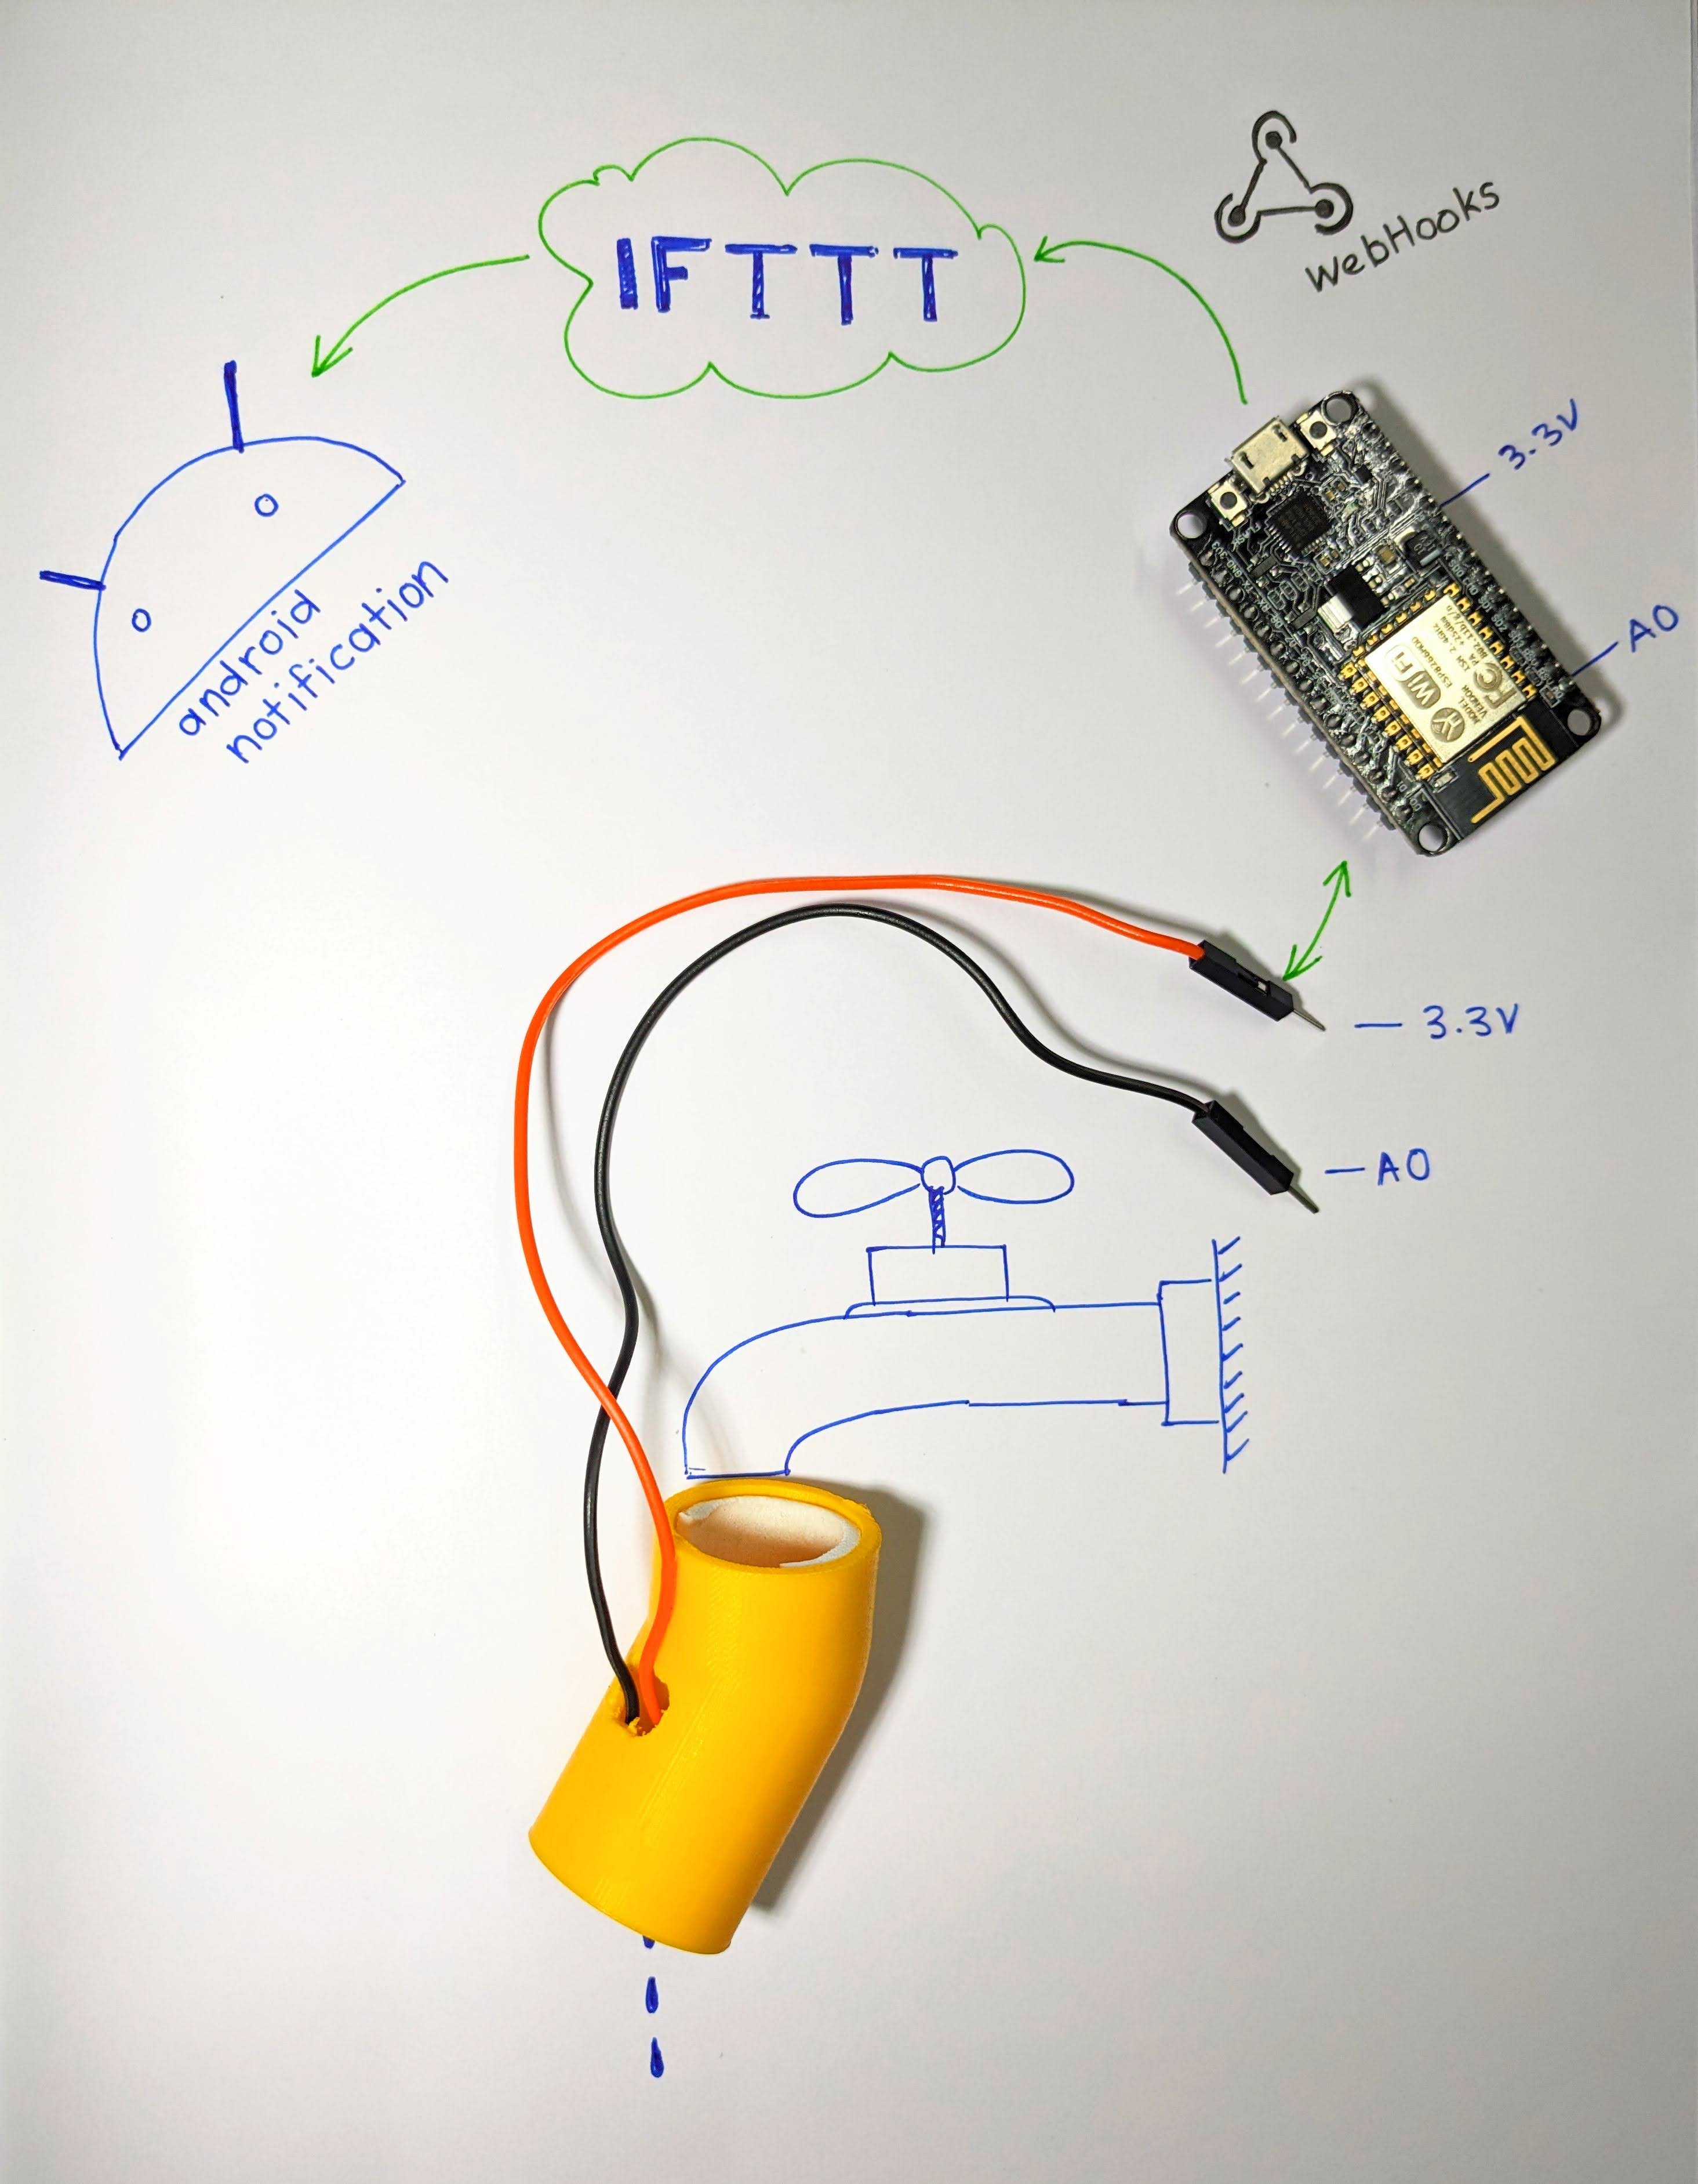Here we have used it to connect Webhooks to Android Notification. So, whenever it receives that web request, a notification will be heard on the Android phone with the same IFTTT account signed in.

**Dimensions:**

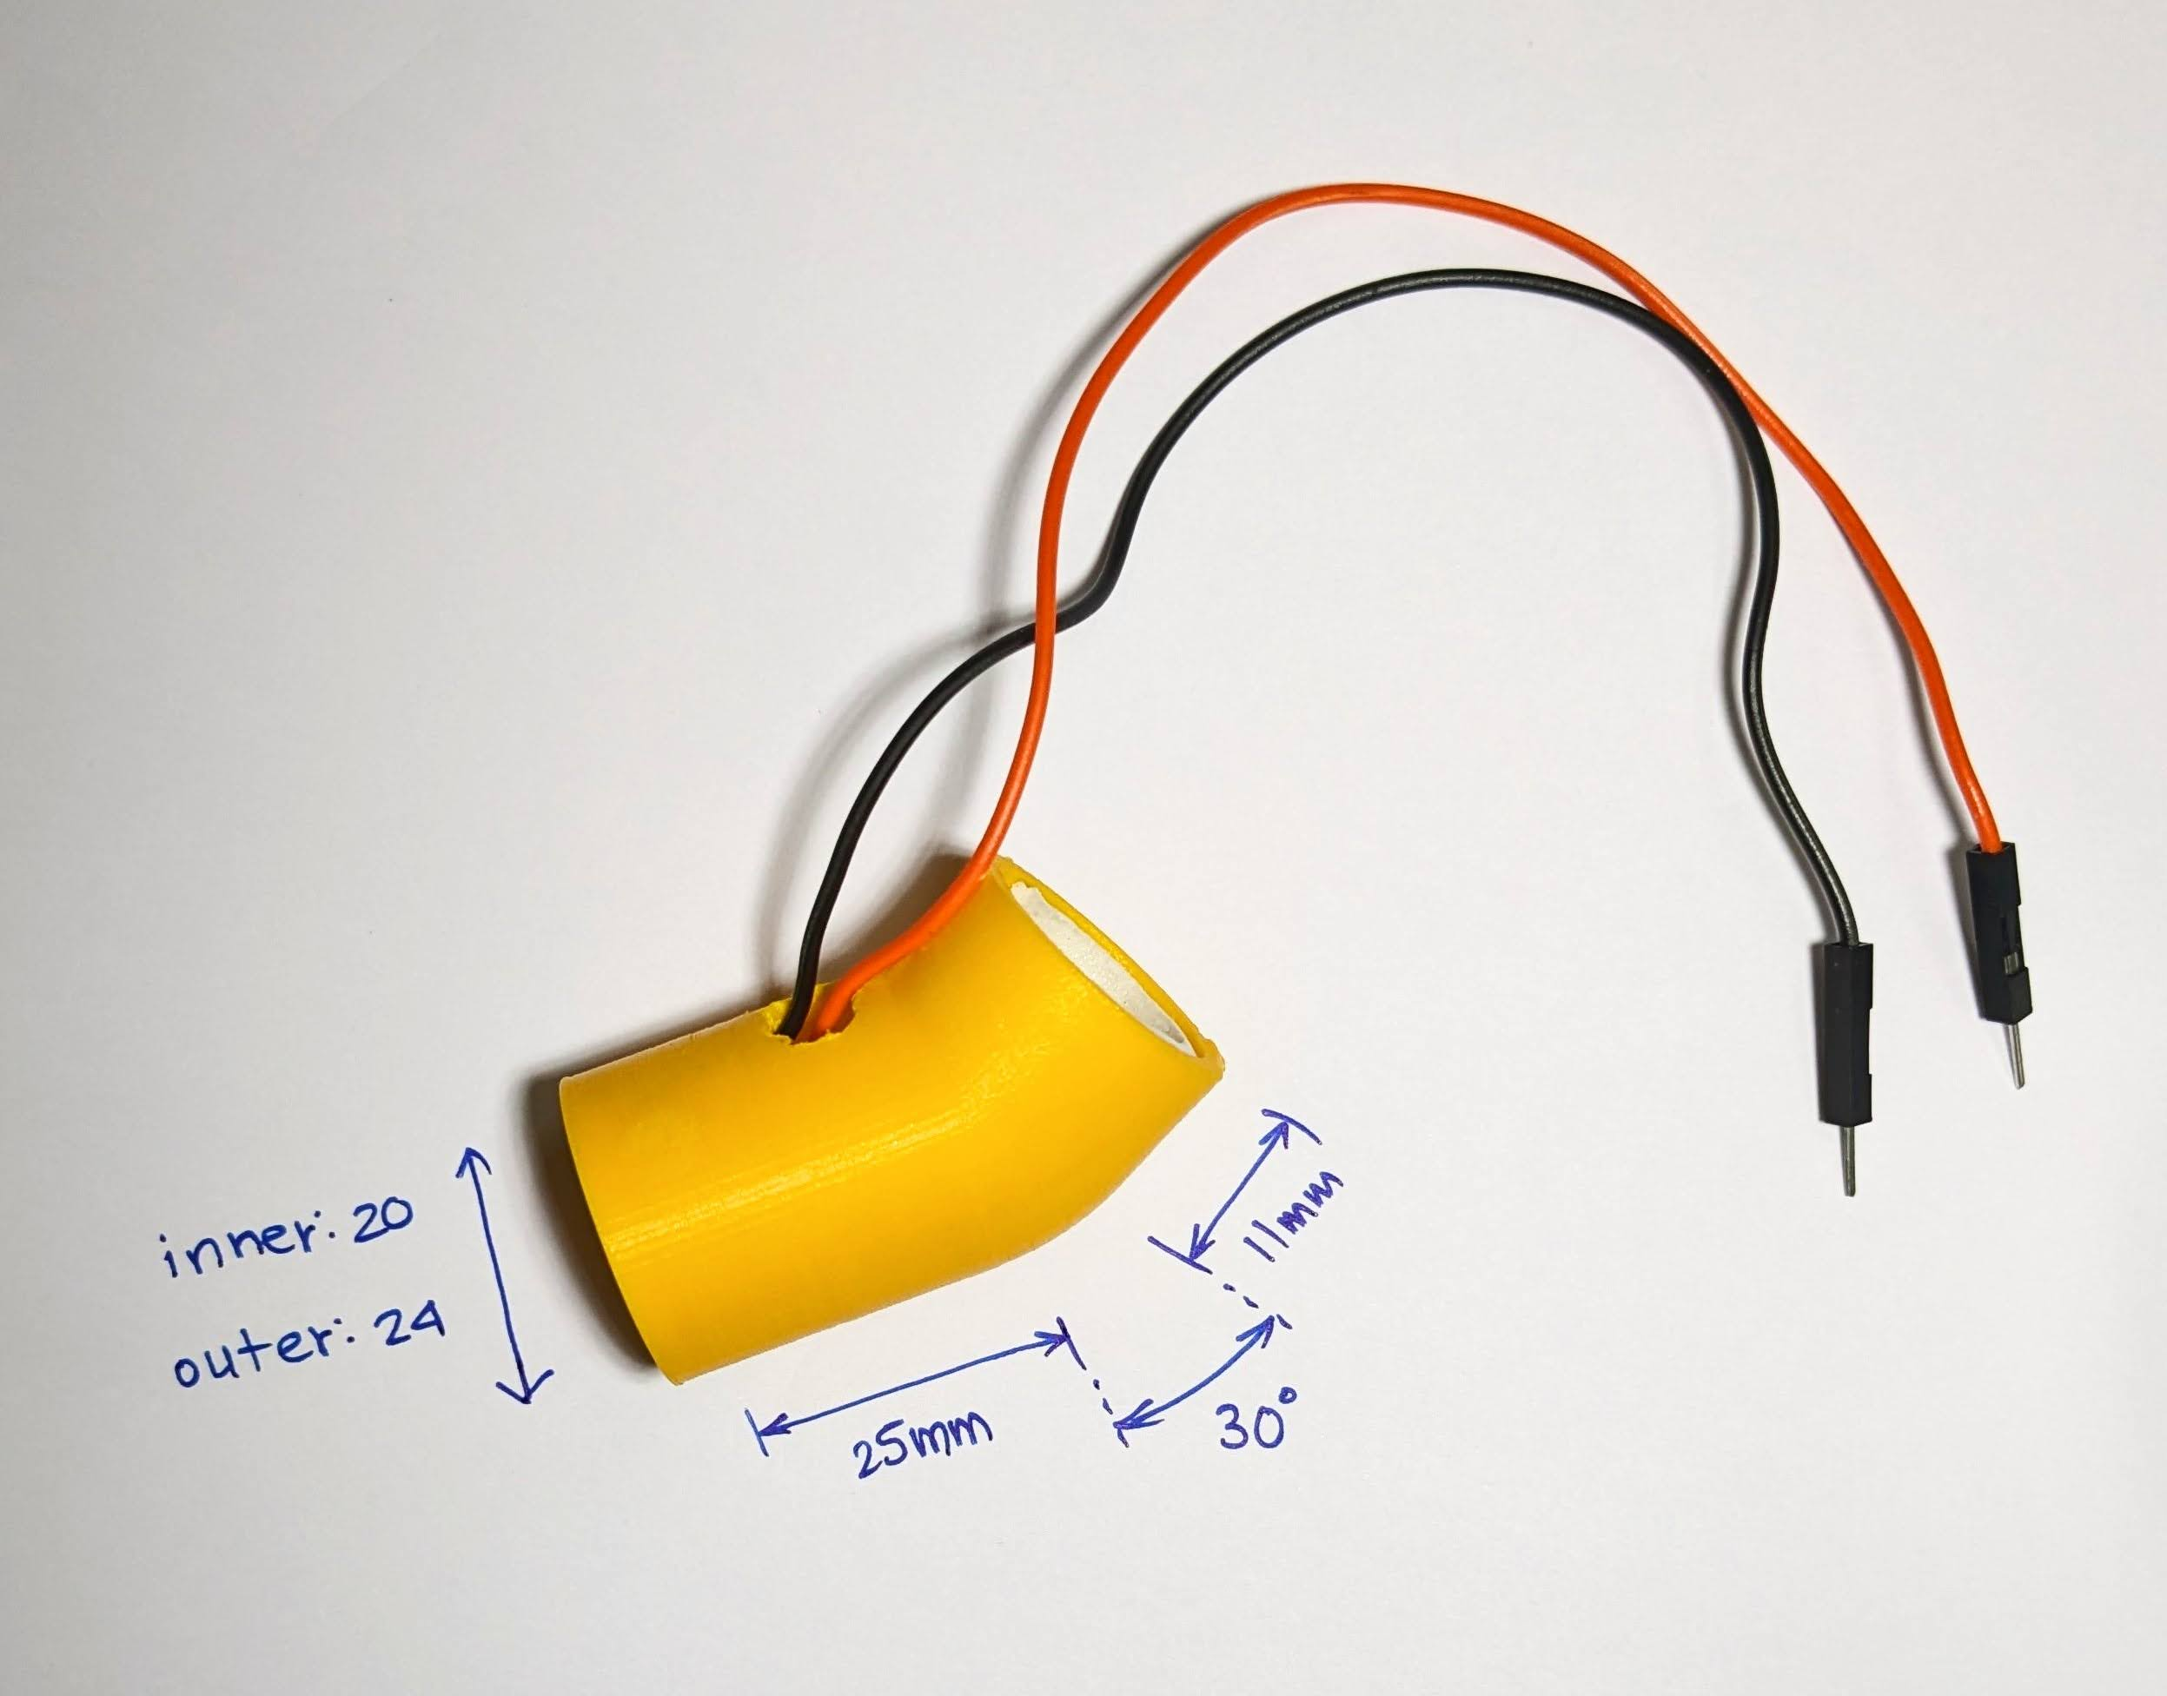25 mm long tube which holds all the sensors, another 12 mm long tube fitted at an angle of 30° to guide the water down to the sensors. Because this is not flexible, these dimensions are made to fit one specific type of tap only.

**Method of fabrication:**

3D printing the tube which is the sensor

**Bill of materials with cost:**Bill 1:

|  |  |  |  |
| --- | --- | --- | --- |
| **Item Name** | **Quantity** | **Rate of item** | **Amount (₹)** |
| **Bread Bard** | 1 | 80 | 80 |
| **Jumper Wire** | 60 | 3 | 180 |
| **9v Battery** | 2 | 25 | 50 |
| **9v Battery Cap** | 2 | 5 | 10 |
| **ESP8266 – NodeMCU** | 1 | 350 | 350 |
| **Electrical Tape** | 1 | 15 | 15 |
| **Resistor Kit** | 1 | 35 | 35 |
| **LED** | 10 | 1 | 10 |
|  |  | **Total without GST** | 730 |
|  |  | **18% GST** | 130 |
|  |  | **Total Amount Paid** | **860** |

Bill 2:

|  |  |  |  |
| --- | --- | --- | --- |
| **Item Name** | **Quantity** | **Rate of item** | **Amount (₹)** |
| **9v Battery** | 2 | 25 | 50 |
| **9v Battery Cap** | 1 | 5 | 5 |
| **Motor Pump** | 1 | 95 | 95 |
| **Tube for pump** | 1 metre | 30 | 30 |
|  |  | **Total without GST** | 180 |
|  |  | **18% GST** | 32 |
|  |  | **Total Amount Paid** | **212** |

Bill 3:

|  |  |  |  |
| --- | --- | --- | --- |
| **Item Name** | **Quantity** | **Rate of item** | **Amount (₹)** |
| **Aluminium Tape** | 1 | 250 | 250 |
|  |  | **Total Amount paid (incl. of GST and Shipping)** | **250** |

Bill 4:

|  |  |  |  |
| --- | --- | --- | --- |
| **Item Name** | **Quantity** | **Rate of item** | **Amount (₹)** |
| **Hydrophobic Film** | 1 | 387 | 387 |
|  |  | **Total Amount paid (incl. of GST and Shipping)** | **387** |

Sub Total of the project in ₹: 860 + 212 + 250 + 387 = 1709

**Tests Conducted:**

1. Testing that it detects water flow reliably under different flow rates.  
   Problems encountered:
   1. Sometimes the water would get stuck between the electrodes, however this is a problem with the 3D printed prototype which can be mitigated by removing one of the ribs causing the issue.
2. Testing that it should connect to the network reliably  
   Problems encountered:
   1. Because the institute is using an open Wi-Fi system which then needs LDAP Credentials to access the internet, we were unable to connect to such a Wi-Fi System. However, we were able to connect to it using a normal encrypted Wi-Fi connection by using a mobile hotspot.
3. Testing that it should send notifications reliably  
   Problems encountered:
   1. We are using the free version of an online service called IFTTT, because of which the time for the notification to arrive is delayed by a few seconds. The premium plan works faster than the free plan. The online service can be completely mitigated by making a server to which the device would connect to, however that is out of the scope of the project.

**Link to recorded video:** [Video](https://drive.google.com/file/d/1LWN1Wnxt_ifaXNUw1MUoPj_QtdFKRtLK/view?usp=sharing)

**Link to GitHub Repository:** [GitHub Repository](https://github.com/Raagam-Parmar/Open_Faucet_Detector)